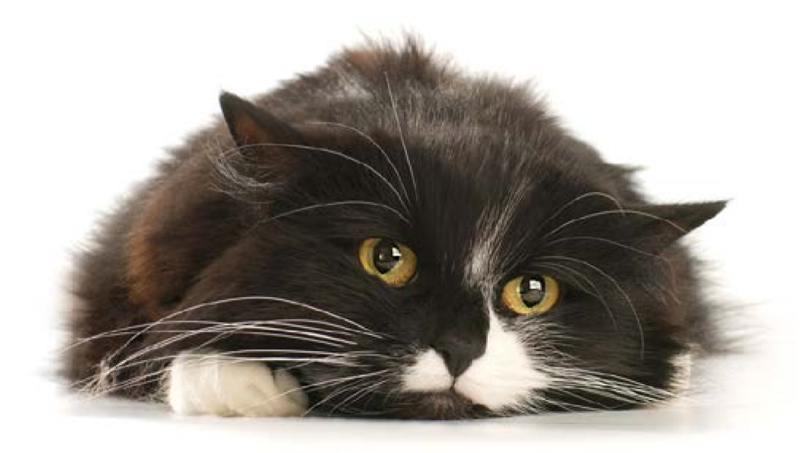
Is My Cat in Pain?

Cats often have pain from arthritis, urinary problems and many other conditions. It can be challenging to tell if your cat hurts, because cats have a strong natural instinct to hide their pain. There are many options to treat pain in cats and give them a more comfortable life. Please use the questions below to help your veterinarian determine if your cat is in pain.

Your Name: _______________________________________________________

Pet’s Name: ________________________________________________________

Check all the things you have noticed in your cat:
- Difficulty or avoids jumping up or down from counters or furniture (does less, falls, or seems clumsy) Difficulty or avoids going up or down stairs
- Difficulty walking or running (limps or moves more slowly) Less playful
- Restlessness or difficulty finding a comfortable position
- Vocalizing (unusual or excessive purring, hissing, growling etc.) when touched or moving
- Rapid, open mouthed or unusual breathing
- Decreased appetite
- Less desire to interact with people or animals (hiding, resistance to being pet, brushed, held or picked up)
- Excessive grooming, licking, biting or scratching a body part
- Sleeping in an unusual position or unusual location
- Unusual aggression when approached or touched (biting, growling, hissing, ears pinned back)
- Changes in eye expression (staring, enlarged pupils, vacant look, squinting)
- Stopped using or has difficulty getting in or out of litter box
- Stopped grooming completely or certain areas of the body
- Other Concerns: ________________________________________________________________________

Did you know that your veterinary care team is a member of the International Veterinary Academy of Pain Management (IVAPM), which is an international organization committed to insuring that animals have a pain free life? For more information and additional resources, visit the “For the Public” section at:
ivapm.org

