FEATURE ARTICLE: Fat Fido's resolution for the new year

As dog and cat obesity grows, help your pet slim down in 2006
By Kim Campbell Thornton

Dear Diary,
Fido here. It’s the holidays, and I’ve been paying very close attention to how my people celebrate them. There’s lots of food involved, and I find that if I stick close, some of it usually comes my way. A little too much, maybe. Last night I heard the woman saying that I looked like a Vienna sausage on toothpicks — and I don’t think she meant it in a nice way.
I’ve noticed that they’re busy thinking up things called New Year’s resolutions, which seem to involve changing themselves for the better. Maybe I should make one to lose a little weight. I’ve been reading up on the latest news about obesity in pets — it’s epidemic, apparently — and here are some ways people can help me (and my other cat and dog friends) look slim and trim next year:
Really look at us
It’s funny how people don’t really seem to see us, even though they’re looking straight at us. I’ve been waddling for months, but my people don’t realize I’m fat. If people would just use their eyes and hands, it would be easy for them to tell if we’re overweight.
Tony Buffington, a professor in the department of veterinary clinical sciences at Ohio State University in Columbus, says that when people look at us from the side, our abdomen should be tucked up. When they look at us from above, we should have an hourglass figure, with the waist curving inward just before the hind legs. When they pet us on the side or back, they should be able to feel the ribs or spinal bumps but not see them. If we look like a basketball with legs and a head, we’re obese. How hard is that?
Get us off the couch and on the move
All my dog pals love a brisk walk or game of fetch — when they can get it.
And my cat buddies go wild for those fishing-pole toys with the mousie or birdie on the end. Sometimes they sit for hours in front of the closet where it’s stored, just hoping someone will bring it out. A few minutes of this several times a day gets them moving.
Veterinarian Jim Richards, director of the Cornell Feline Health Center in Ithaca, N.Y., says to encourage activity by wiggling the pole so the object on the end of the string mimics a little critter scurrying along the ground or around a door. If you don’t tell them it’s a cat toy, dogs think chasing the fishing pole is a fun game, too.
Give cats an indoor 'tree' to climb
Achieve this by providing a scratching post that’s at least 4-6 feet tall. Some go all the way to the ceiling. Those rock!
Measure our food
It’s easy just to leave food out for us all the time, but in case you haven’t sampled it, that stuff is tasty! It’s hard to just say no, especially when there’s not much else to do around the house when you’re gone. Consult our veterinarian about the amount we should be eating. Cats, especially, shouldn’t go on crash diets.
“There can be some really serious hits on their health when cats lose weight too quickly,” Richards says. Obese cats that lose weight rapidly are prone to a condition called hepatic lipidosis, or fatty liver disease, which can be fatal. Slow and steady weight loss is the way to go.
Consider 'Catkins' diet for feline friends
A cat’s natural diet is mainly meat, and recent research in feline nutrition shows that cats do well on a high-protein, low-carb diet, says veterinarian Susan Little of Ottawa, Canada, president of the Winn Feline Foundation.
“We’ve been getting away for years by feeding cats dry foods with high-carb content because they can live on it,” she says. “It’s technically nutritionally complete, but the price they pay is that those excess carbs are stored as fat, which is why we’ve got this epidemic of obesity. It’s easily the most common health problem in cats; 40 to 50 percent of cats are obese.”
Lacking a regular supply of mice, or faced with a cat that turns up its nose at a diet prescribed by the veterinarian, try switching to a good-quality canned food. “All canned foods are lower in carbs than dry foods,” Little says. “Even that little switch can make a difference.”
Make us work for our meals
I think I can safely speak for other pets when I say there’s nothing to do all day but eat and sleep. “Hunting” for food would help me and my friends feel as if we’re living up to our potential. You can place small amounts of dry food in different areas of the house for us to find during the day, put food up on the washer or dryer so cats will have to make a bit of an effort to get to it, or put it inside food puzzles such as Buster Cubes so we have to work to get it out.
Little says you can make a food puzzle at home by taking a clean yogurt container with a lid and poking a hole in it that’s just a little bit bigger than pieces of dry cat or dog food. Put the dry food in the yogurt container, put the lid on and then show your pet how to bat and roll the container so a few pieces of food at a time will drop out.
Back off on the treats
Sure, we like them, but they’re not what we’re all about. Sometimes, we just want attention. When we rub up against you or nudge your hand, try playing with us, petting us or running us through a quick obedience routine — then reward us with a piece of kibble instead of that potato chip or french fry you’re eating.
You know, losing weight is just as healthful for us as it is for you. Fat cats and dogs are more prone to musculoskeletal problems that contribute to arthritis. All that extra weight on our joints makes us more likely to suffer soft-tissue injuries, too. It’s harder for my fat-cat buddies to groom themselves, so they develop skin problems. And the big bad that’s linked to obesity is diabetes. Believe me, you don’t want to start having to give us insulin shots.
So anyway, that’s my New Year’s resolution. Maybe one of yours will be to help me achieve it.
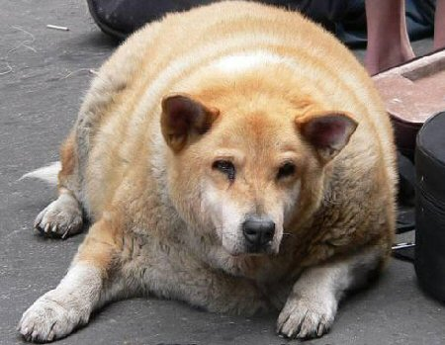
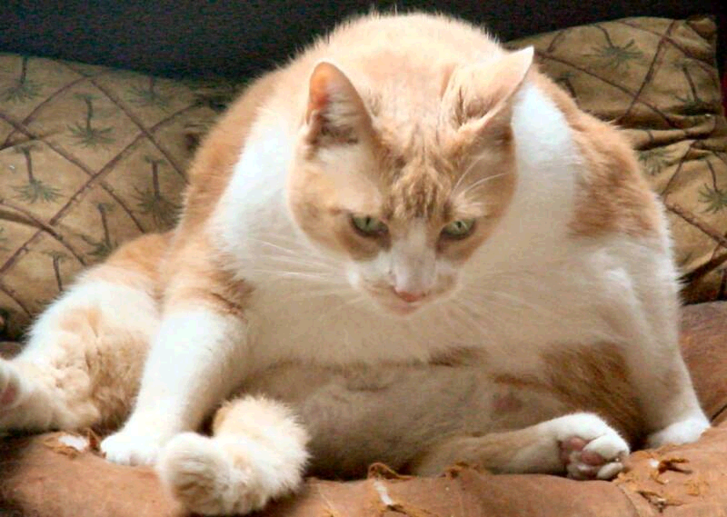


Dr. Martins helps many dogs and their owners by offering canine behavior consults here at Belle Mead Animal Hospital.
He evaluates the dog and it’s owner, discusses and assesses the primary problem and any concerns. Most cases are wonderful, concerned owners who have had dogs past and present for years. Unfortunately, their techniques are not working or providing consistent results. Most clients come in thinking their dog is “psycho,” “stubborn,” “aggressive,” “uncontrollable,” and “untrainable.”
Dr. Martins takes these dogs and shows the owners five basic techniques in just 20 minutes that will make a significant improvement both their lives. As they say: “seeing is believing.” During these consults, owners are amazed at how wonderful their dog has become in such a short time.
Dr. Martins will create a specialized plan for the owners allowing them to continue the training at home. Once the dog knows what it’s job truly is and what is expected from him, owners will see that even their “problem child” can become the best dog they’ve ever had. Call and make an appointment for a behavior consult today!
10% off

BEHAVIOR CONSULT
Good thru February 28, 2007
$5.00 off
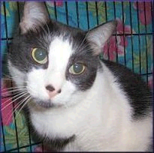
FeLeuk/FIV Test
Good thru February 28, 2007 on any new kitten or outdoor cat



January is
Spay and Neuter Awareness Month!
What do “spay” and “neuter” really mean?
Female dogs and cats are spayed by removing their reproductive organs, and male cats and dogs are neutered by removing their testicles. In both cases the operation is performed while the pet is under anesthesia. Depending on your pet’s age, size, and health, he or she will stay here at the hospital for a few hours or overnight. Depending on the procedure, your pet may need stitches removed after a few days. Your veterinarian will be happy to fully explain spay and neuter procedures to you and discuss with you the best age at which to sterilize your pet.

Spaying or Neutering Is Good for Your Pet
- Spaying and neutering helps dogs and cats live longer, healthier lives.
- Spaying and neutering can eliminate or reduce the incidence of a number of health problems that can be very costly and difficult to treat.
- Spaying eliminates the possibility of uterine or ovarian cancer and greatly reduces the incidence of breast cancer, particularly when your pet is spayed before her first estrous cycle.
- Neutering eliminates testicular cancer and decreases the incidence of prostate disease.
- In males especially, it’s virtually torture not to neuter them if you’re not a responsible breeder. Males typically start marking their territory by urinating around the house after six months of age.
- Did you know that one intact cat can produce 40,000 kittens in five years with only two surviving kittens per litter? Pretty sad!
- Guess what? If you spay your dog before its first heat you reduce her risk of breast cancer from 25% to 1%!

Spaying or Neutering Is Good for You
- Spaying and neutering makes pets better, more affectionate companions.
- Neutering cats makes them less likely to spray and mark territory.
- Spaying a dog or cat eliminates her heat cycle. Estrus lasts an average of six to twelve days, often twice a year, in dogs and an average of six to seven days, three or more times a year, in cats. Females in heat can cry incessantly, show nervous behavior, and attract unwanted male animals.
- Unsterilized animals often exhibit more behavior and temperament problems than do those that have been spayed or neutered.
- Spaying and neutering can make pets less likely to bite.
- Neutering makes pets less likely to roam the neighborhood, run away, or get into fights.

Spaying and Neutering Are Good for the Community
- Communities spend millions of dollars to control unwanted animals.
- Irresponsible breeding contributes to the problem of dog bites and attacks.
- Animal shelters are overburdened with surplus animals.
- Stray pets and homeless animals get into trash containers, defecate in public areas or on private lawns, and frighten or anger people who have no understanding of their misery or needs.
- Some stray animals also scare away or kill birds and wildlife.

Fix That Bunny!
When being conscientious about the pet overpopulation, don’t forget to spay or neuter your pet rabbit. Altering rabbits can reduce hormone-driven behavior such as lunging, mounting, spraying, and boxing. Spaying females can prevent ovarian, mammarian, and uterine cancers, which can be prevalent in mature does. Did you know that 50% of female rabbits over the age of four will get uterine cancer suddenly which will cause them to bleed to death? This unfortunate condition can be completely preventable if your rabbit is spayed! Also, rabbits reproduce faster than dogs or cats and are the third-most animal surrendered to shelters.

Spay or neuter surgery carries a one-time cost that is relatively small when one considers its benefits. It’s a small price to pay for the health of your pet and the prevention of more unwanted animals.
A tomcat was heard running up and down the
alley for hours. A neighbor called his owner and asked what was happening. The owner said, "Well, I had him fixed today, and he's going around canceling all his engagements."


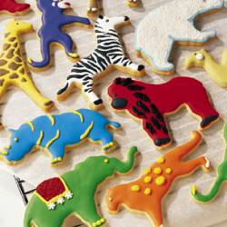
Happy New Year!!!

January 2007
BRRRR!!!

Top Ten Cold Weather Tips
It’s cold out! The following guidelines will help you protect your companion animals when the mercury dips.

- Keep your cat inside. Outdoors, felines can freeze, become lost or be stolen, injured or killed. Cats who are allowed to stray are exposed to infectious diseases, including rabies, from other cats, dogs and wildlife.

- During the winter, outdoor cats sometimes sleep under the hoods of cars. When the motor is started, the cat can be injured or killed by the fan belt. If there are outdoor cats in your area, bang loudly on the car hood before starting the engine to give the cat a chance to escape.

- Never let your dog off the leash on snow or ice, especially during a snowstorm – dogs can lose their scent and easily become lost. More dogs are lost during the winter than during any other season, so make sure yours always wears ID tags.

- Thoroughly wipe off your dog’s legs and stomach when he comes in out of the sleet, snow or ice. He can ingest salt, antifreeze or other potentially dangerous chemicals while licking his paws, and his paw pads may also bleed from snow or encrusted ice.

- Never shave your dog down to the skin in winter, as a longer coat will provide more warmth. When you bathe your dog in the colder months, be sure to completely dry him before taking him out for a walk. Own a short-haired breed? Consider getting him a coat or sweater with a high collar or turtleneck with coverage from the base of the tail to the belly. For many dogs, this is regulation winter wear.

- Never leave your dog or cat alone in a car during cold weather. A car can act as a refrigerator in the winter, holding in the cold and causing the animal to freeze to death.

- Puppies do not tolerate the cold as well as adult dogs, and may be difficult to housebreak during the winter. If your puppy appears to be sensitive to the weather, you may opt to paper train him inside. If your dog is sensitive to the cold due to age, illness or breed type, take him outdoors only to relieve himself.

- Does your dog spend a lot of time engaged in outdoor activities? Increase his supply of food, particularly protein, to keep him -and his fur- in tip-top shape.

- Like coolant, antifreeze is a lethal poison for dogs and cats. Be sure to thoroughly clean up any spills from your vehicle, and consider using products that contain propylene glycol rather than ethylene glycol.

- Make sure your companion animal has a warm place to sleep, off the floor and away from all drafts. A cozy dog or cat bed with a warm blanket or pillow is perfect.
Drop The Ball! Muffins (for dogs)

Ingredients:
2 Tbsp. honey
2 ¾ c. water
¼ c. unsweetened applesauce
1/8 tsp. vanilla
1 egg
½ c. chopped peanuts
4 c. whole wheat flour
1 Tbsp. baking powder
1 Tbsp. cinnamon
1 Tbsp. nutmeg

Preparation: Preheat oven to 350. In a bowl, mix together the honey, water, applesauce, vanilla and egg. In another bowl, mix peanuts, flour, baking powder, cinnamon and nutmeg. Add wet ingredients and stir, mixing well. Spoon into a greased muffin tin, filling each cup 2/3 full. Bake for 35 minutes. Store in a sealed container.
Bakes 16 muffins.
New Year’s Tuna Nibbles (for cats)

Ingredients:
1 – 8 oz. Can tuna (in oil)
2 c. cornmeal
2 c. flour
¾ c. water
2/3 c. veg. Oil
½ tsp. salt

Preparation:
Mix all ingredients well, kneading just to combine. On floured surface, roll out to ¼” thickness. Cut out into little squares or other shapes. Place on greased baking rack. Bake at 350 for 25-30 minutes. Cool on a wire rack. Store in an airtight container in the fridge.
The Quarterly Newsletter from
Belle Mead Animal Hospital
animal crackers

